PrincessSumaya University for Technology

King Abdullah II Faculty of Engineering

Electrical Engineering Department



|  |
| --- |
| **Embedded Systems Lab (22448)**  **Final Design. Project**  **Model-Based PID Ball Balancing System** |

|  |  |  |  |
| --- | --- | --- | --- |
| *Authors: ￼* |  |  | *Supervisor:* |
| Mohammad Abdalaziz  Alaa Rifai  Zaid Banna | 20200168  20190995  20201026 | C.E Engineering  C.E Engineering  C.E Engineering | Prof. Esam Alqaralleh  Eng. Abdulghani Aljundi |

*May 29, 2024*

***Abstract***

This project utilizes a servo motor, an ultrasonic sensor, and potentiometers to create a ball-balancing system using Arduino. The system adjusts the angle of a track to maintain the ball at a specific position. The ultrasonic sensor detects the ball's location, and a PID controller corrects any deviations to ensure stability. The servo motor moves the track vertically to guide the ball back to its designated position. Simulink-based software is used to develop a prototype, documentation, and presentations. Evaluation criteria include system setup, software design, PID tuning, report quality, presentation, teamwork, and understanding. This project offers practical experience with embedded systems and control theory.

Table of Contents

1 Introduction 2

1.1 Objectives 2

1.2 Theory 2

1.3 Equations Guidelines 2

2 Procedure and Methods 4

3 Results and Discussions 6

4 Conclusions 7

5 References 7

# Introduction

In this experiment, we are developing a system to maintain a ball's position on a track using Arduino, a servo motor, an ultrasonic sensor, and potentiometers. The primary objective is to keep the ball stable in a specific location. We are applying control theory, specifically PID (Proportional-Integral-Derivative) control, to accomplish this. Through this project, we will gain practical experience in real-time system control and its applications.

## Objectives

Develop a ball-balancing system using Arduino, a servo motor, an ultrasonic sensor, and potentiometers.

Evaluate the system's capability to maintain the ball's stability on a track despite disturbances.

Implement and apply PID (Proportional-Integral-Derivative) control theory in practice.

Test and analyze the performance of the control system.

Gain insights into embedded systems, control theory, and their real-world applications.

Recognize the significance of control theory in engineering.

## Theory

The Proportional-Integral-Derivative (PID) controller is a fundamental feedback control mechanism utilized in engineering and automation systems. Its purpose is to periodically adjust a system's output to achieve and maintain a desired setpoint or target value. The PID controller integrates three control actions: proportional (P), integral (I), and derivative (D). Each action contributes to the overall control signal based on the difference between the target value and the system's output.

## Equations Guidelines

To present the equation in a clear way, define all variables used in the equation. Follow these steps to ensure clear presentation of equations:

1. **Proportional (P):**

The proportional term is determined by multiplying the proportional gain (𝐾𝑝) by the error

(Err)Its immediate effect on the output aims to bring the process value close to the setpoint. The proportional value's impact decreases as the error diminishes.

$P=K_{p}* E_{rr}$ ( 1 )

1. **Integral (I):**

The integral term is obtained by multiplying the integral gain (𝐾𝑖) by the error, then by the controller's cycle time. This term accumulates over time, correcting steady-state errors by continuously adjusting the output.

$I=K_{i}* E_{rr}*dt$ ( 2 )

1. **Derivative (D):**

The derivative term (𝐷) is calculated by dividing the derivative gain (𝐾𝑑) by the change in error over time (𝑑𝑡). It aims to predict the system's future behavior and counteract rapid changes in the process value, thereby preventing overshoot or undershoot.

$D=\frac{K_{d}*(Err-pErr)}{dt}$ ​ 3)

Figure 1

# Procedure and Methods

This project utilized various hardware components and innovative design concepts to create the physical structure. An ultrasonic sensor measures the ball's distance from the edge, while a servo motor adjusts the surface accordingly. Three potentiometers allow for manual adjustment of the P, I, and D values to fine-tune the controller's performance. On the software side, MATLAB Simulink is employed for development. As shown in Figure 2, this is the code used to achieve our desired outcome.

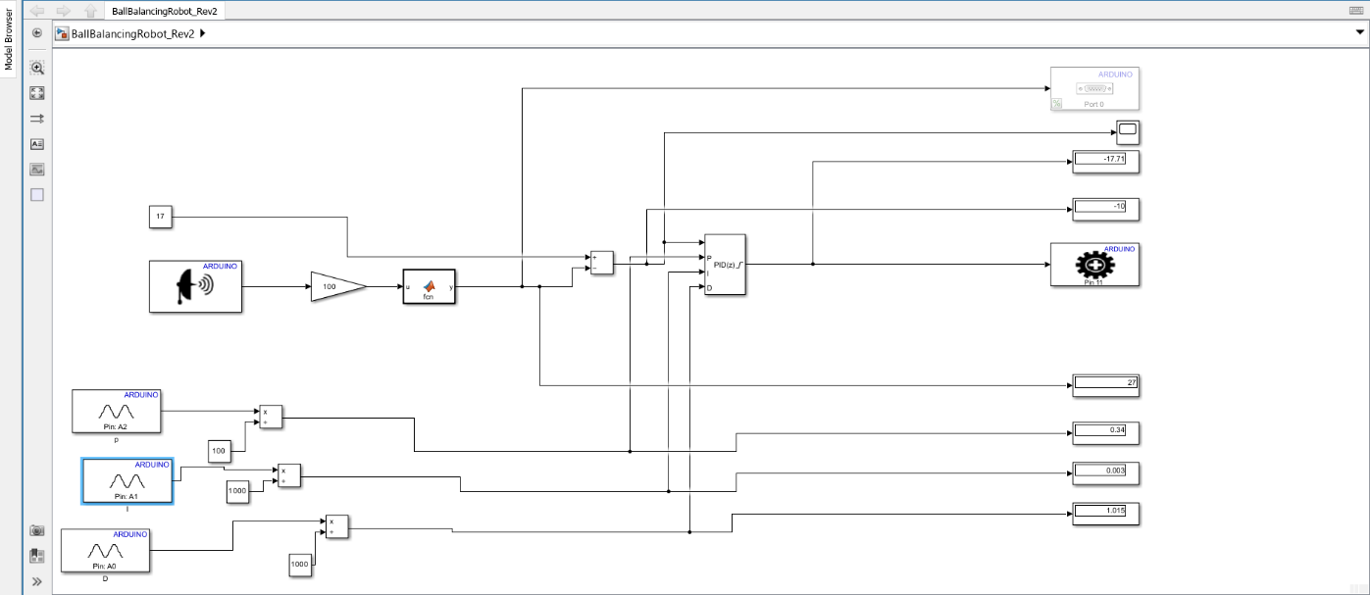

Figure 2 MATLAB Simulink Code

The hardware part shown in figure 3 shows how we connected our components. We used Arduino uno, a servo motor, ultrasonic, and 3 potentiometers to adjust the P, I, D values.

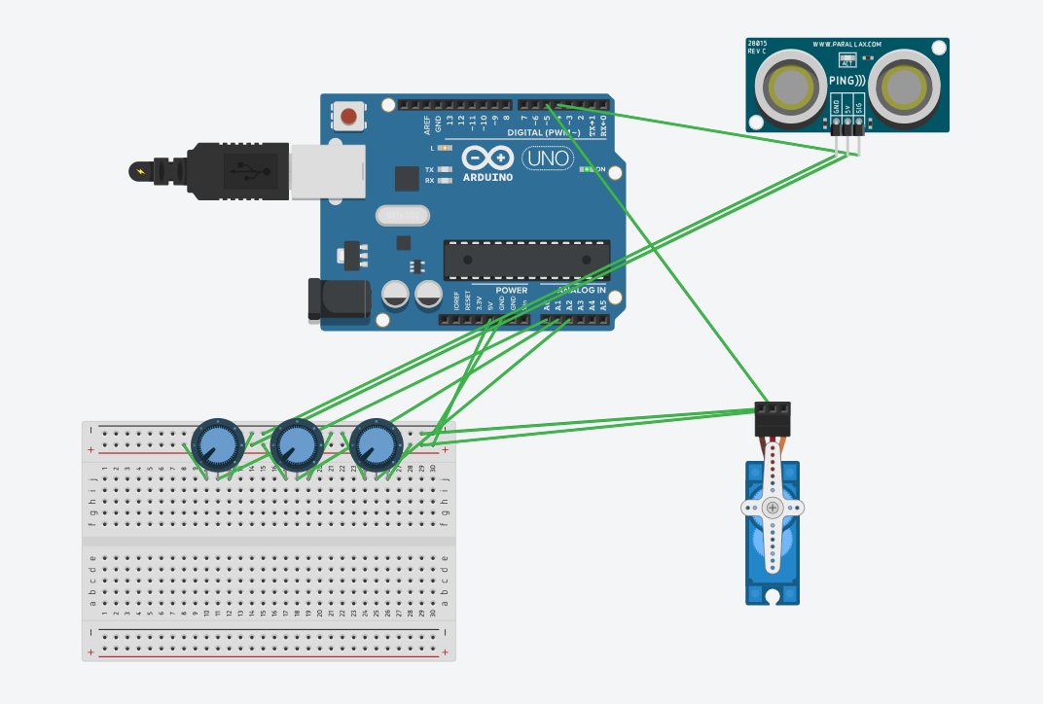

Figure 3 Circuit controlling the system

To test the efficiency of the controller, a physical prototype was built. The prototype mimics the desired ball-balancing. Figure 4 shows the prototype built.

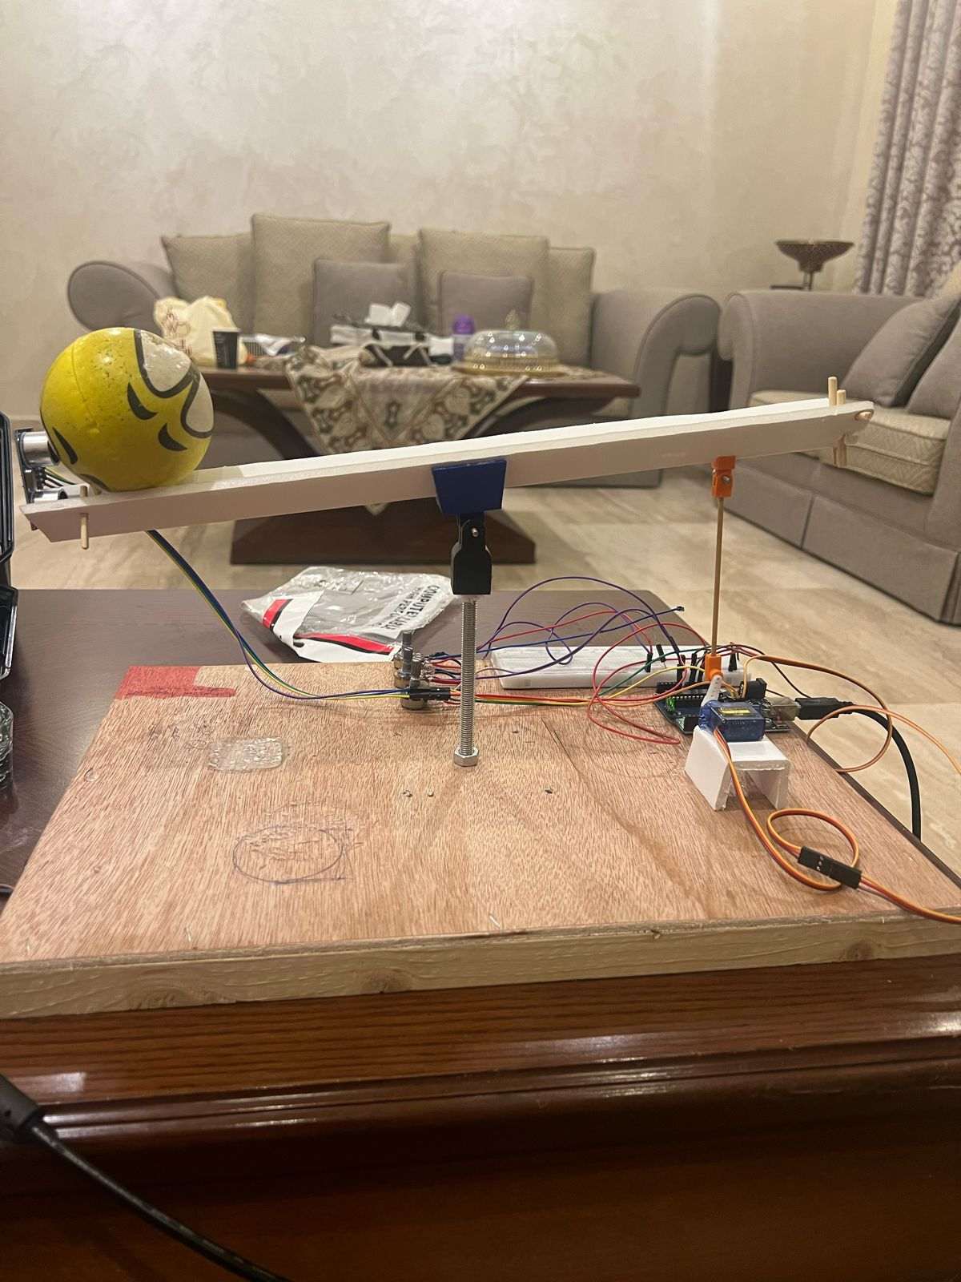

Figure 4 Prototype

# Results and Discussions

As found by this experiment, the optimal values of Ki, Kp, and Kd are determined to balance a small Styrofoam ball by a PID controlled systems. The values are Ki= 1.4, Kp=1.92, and Kd= 0.7



Figure 5

Finally figure 6 depicts clearly how the distance of the ball kept changing as the servo motor kept rotating the surface.

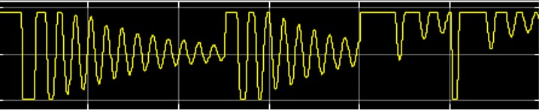

Figure 6

# Conclusions

This experiment demonstrated the practical application of PID control theory in developing a ball-balancing system. By integrating proportional, integral, and derivative terms, we successfully maintained the ball's position on the track despite external disturbances. Although the results were promising, we noted limitations such as sensor accuracy and mechanical constraints. Future research could investigate advanced control strategies and sensor improvements. Overall, this study has significant implications for robotics, automation, and industrial control systems, presenting opportunities for further advancements in control algorithms and system reliability.

# References

|  |
| --- |
| https://docs.arduino.cc/learn/electronics/servo-motors/ |
| |  |  | | --- | --- | | https://www.mathworks.com/products/simulink.html#:~:text=Simulink%20is%20a%20block%20diagram,Get%20a%20free%20trial  https://blogs.mathworks.com/simulink/2013/04/21/implementing-a-pid-controller-on-an-arduino-board/ |  | |